**Docker Task -2**

**Task Description:**

Create a dockerfile, docker-compose file which when executed must display your basic details in the website.

Explanation:

1. Sign in to AWS Console

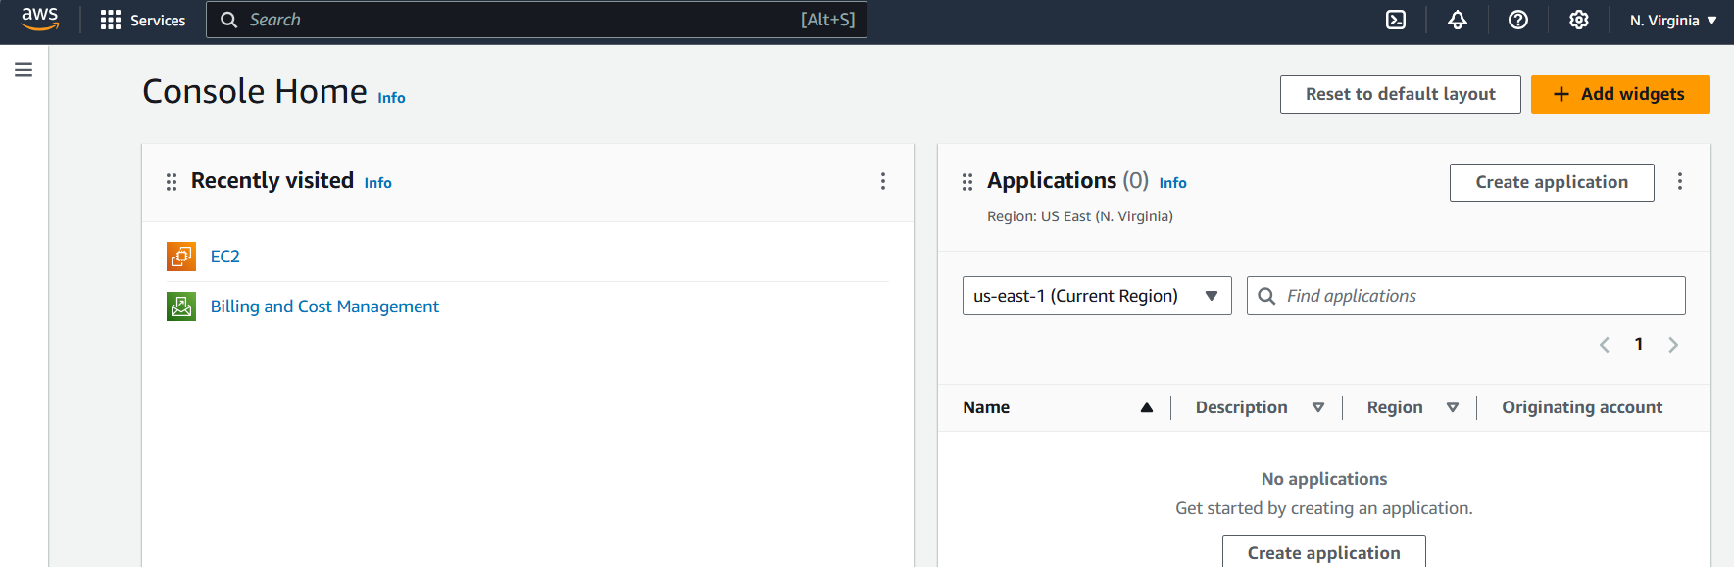

1. Launch an EC2 instance

Navigate to the EC2 Dashboard

Click on Launch Instance.

Choose an Amazon Machine Image (AMI)- Ubuntu-based image

Choose an Instance Type - t2.micro

Review and Launch the instance.

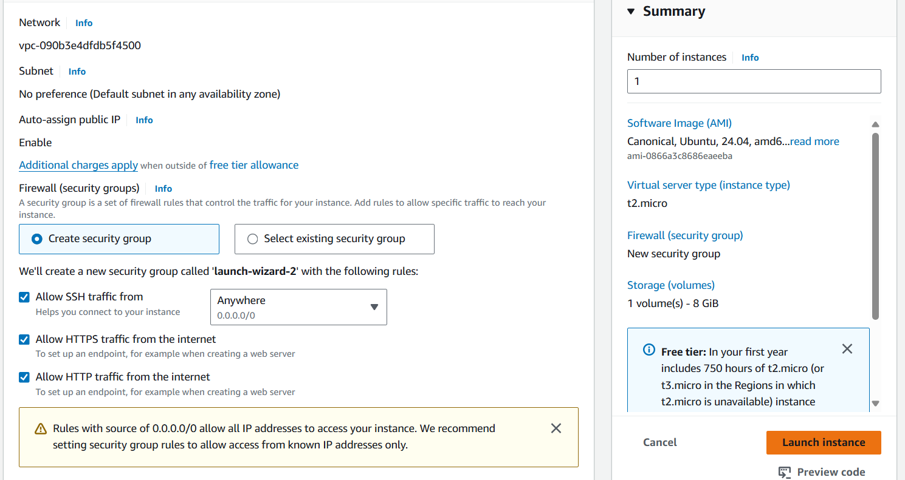

1. Connect to EC2 Instance

Once the instance is running, click View Instances.

Select the instance,click on Connect.

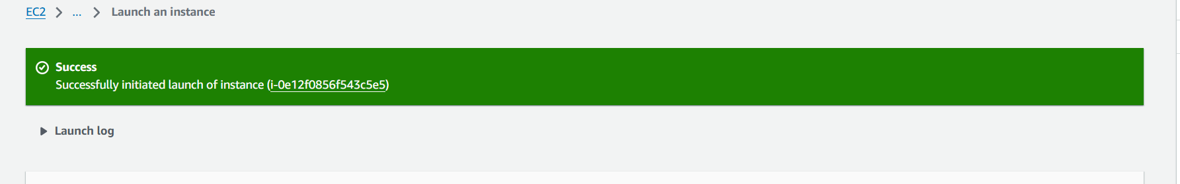

1. Use the SSH client tab instructions to connect to the instance using a terminal

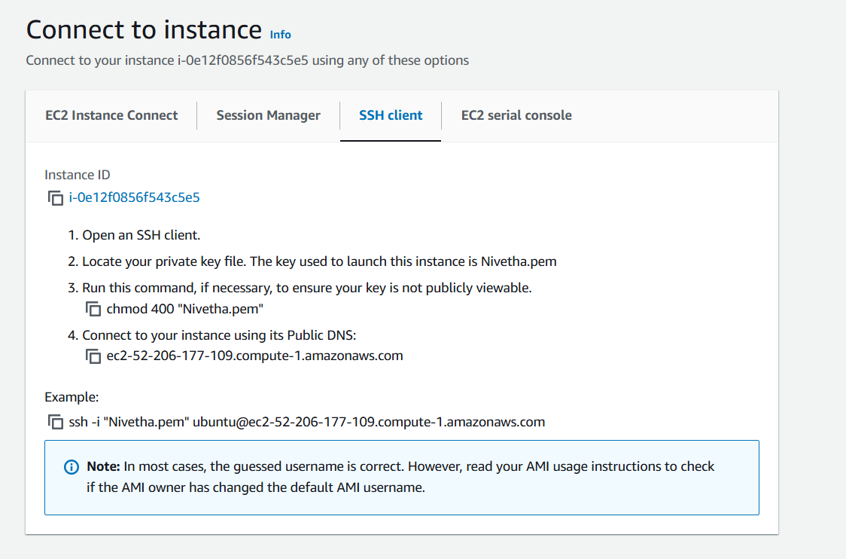

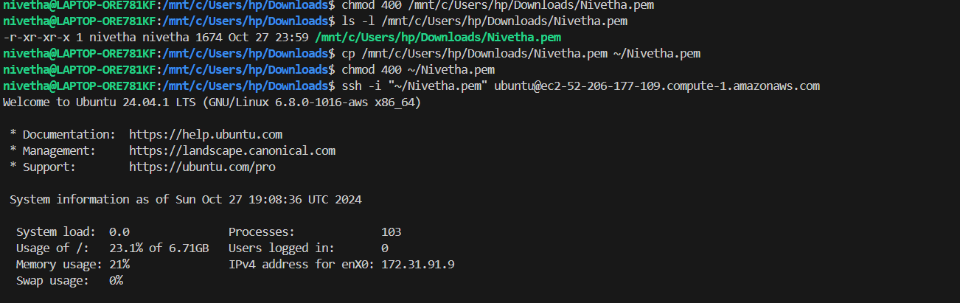

1. Install Docker

Update package - sudo apt-get update

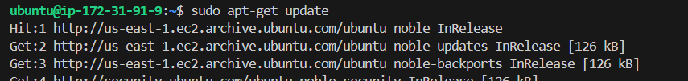

Install Docker- sudo apt-get install docker.io

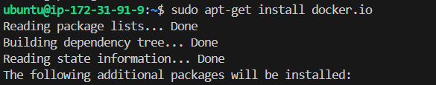

Start and Enable - sudo systemctl start docker

sudo systemctl enable docker

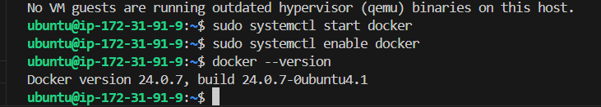

1. Create Project Directory and Files

Create a Directory - mkdir my_website

cd my_website

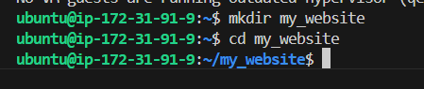

Create index.html - nano index.html and add the following content

<!DOCTYPE html>

<html>

<head>

<title>My Details</title>

</head>

<body>

<h1>Welcome to My Personal Site</h1>

<p>Name: [Nivetha]</p>

<p>Email: [nivethadhaksha@gmail.com]</p>

<p>Profession: [HR]</p>

</body>

</html>

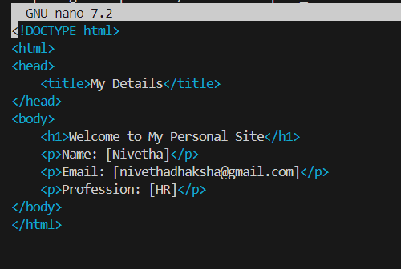

1. Create the Dockerfile - nano Dockerfile and add the following content

FROM nginx:latest

COPY index.html /usr/share/nginx/html/index.html

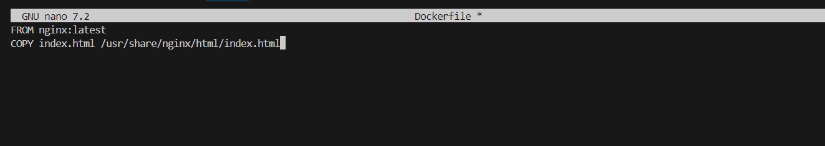

1. Create the Docker Compose File

nano docker-compose.yml and add

version: '3'

services:

web:

build: .

ports:

- "80:80"

This files tells the docker compose to build the file in the current directory and map the container port 80 to EC2 port 80 to access.

1. Build and Run the Docker Containers

Build - sudo docker-compose build

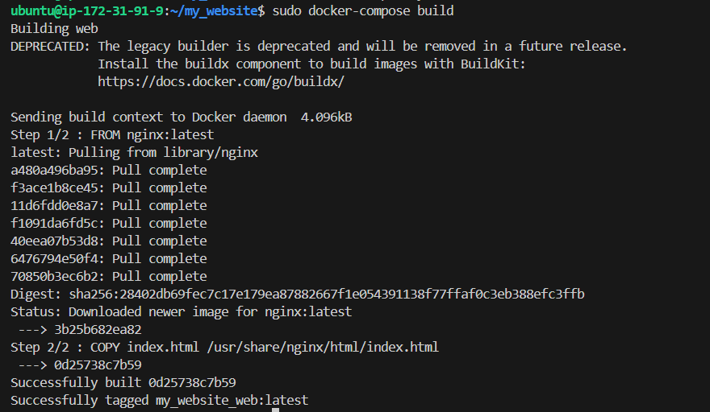

Run - sudo docker-compose up -d

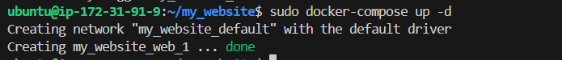

1. View the Website

Visit AWS console, copy the public ipv4 address.

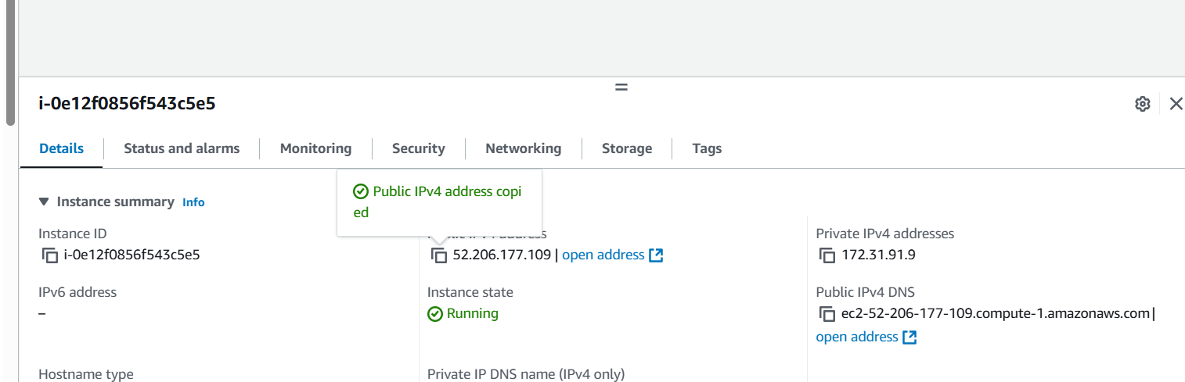

In the browser type http:// 52.206.177.109

